**User Documents**

**Introduce:**

The Huawei CloudSeeker project is a comprehensive cloud-based tool designed to manage, analyze, and interact with data related to cloud computing and technology. This platform is tailored to assist users in exploring a variety of cloud-related topics through an intuitive interface, offering features such as term management, data search, detailed statistics, and chatbot interaction.

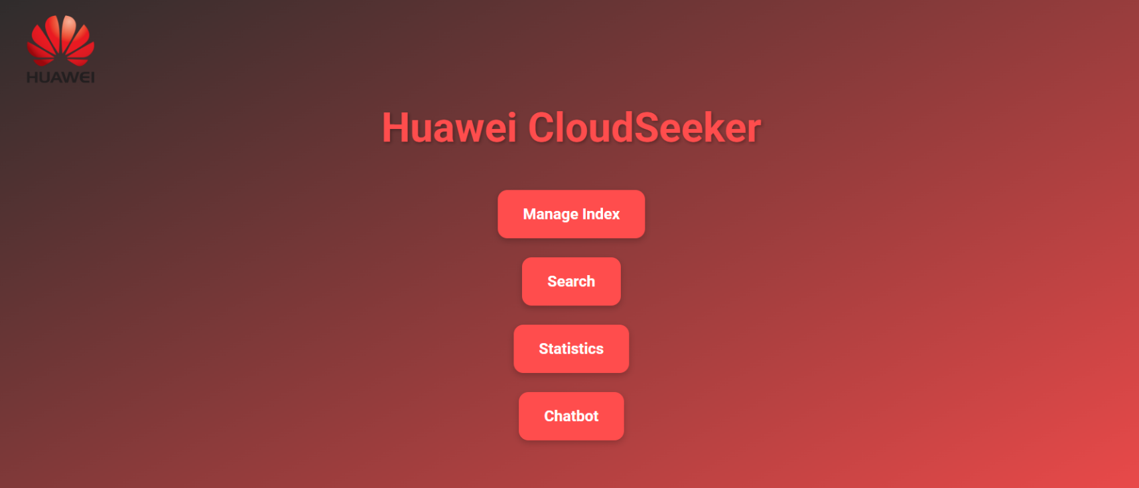**Screen Overview: Huawei CloudSeeker - Main Dashboard**

This is the **main dashboard** for the "CloudSeeker" project. The dashboard contains a header and four main interactive buttons, each corresponding to a specific feature of the system. Below is a detailed explanation of each button and its associated functionality:

1. **"Manage Index" Button  
   Functionality:**
   * Redirects the user to the "Index Management" screen.
   * Allows the admin to do editing to the index.
2. **"Search" Button**
   * **Functionality :** Opens the "Search" module, where users can enter keywords or phrases to search within the indexed data.
3. **"Statistics" Button**
   * **Functionality :** Leads to the "Statistics" screen, where users can check the most searched terms or popular keywords.
4. **"Chatbot" Button**
   * **Functionality :** Opens the chatbot interface, which allows users to interact with an hardcoded “chatbot” assistant.

**Screen Overview: Manage Index - Admin Panel**

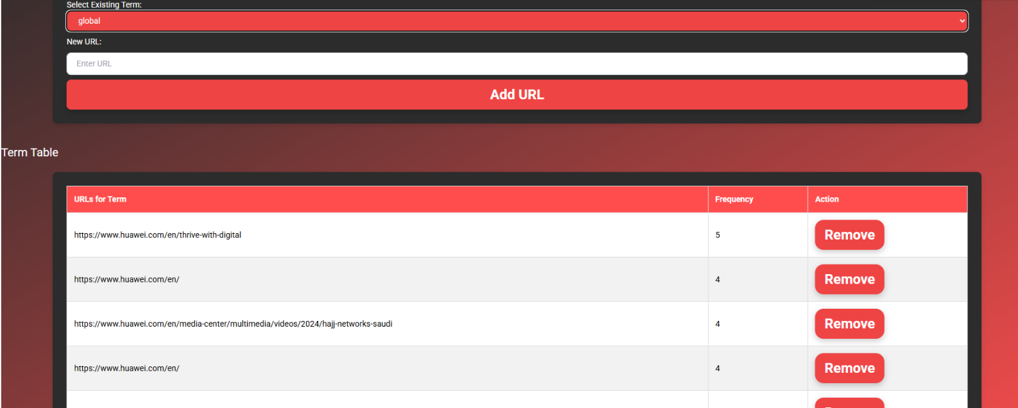 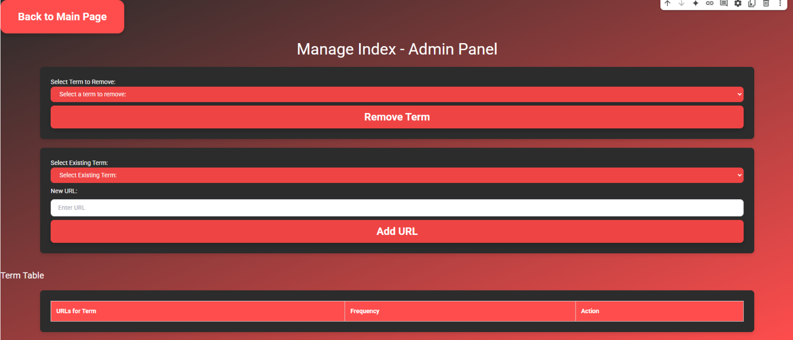

The **Manage Index** screen provides administrative functionality for managing terms and associated URLs within the system. Below is a detailed explanation of each component and its associated functionality:

1. **"Back to Main Page" Button**
   * **Functionality**: Redirects the user back to the main dashboard.
2. **"Remove Term" Section**
   * **Select Term to Remove**: A dropdown list where the admin can select a term to remove from the index.
   * **Remove Term Button**: This button removes the selected term from the index.
3. **"Add URL" Section**
   * **Select Existing Term**: A dropdown list where the admin can select an existing term from the index to which they want to add a new URL.
   * **New URL**: A text input field where the admin can enter a new URL to be associated with the selected term.
   * **Add URL Button**: This button adds the new URL to the selected term.
4. **Term Table**
   * **URLs for Term**: Displays the list of URLs associated with the selected term.
   * **Frequency**: Displays the frequency of occurrences for each URL in the indexed data.
   * **Action**: Each URL has a **Remove** button, allowing the user to delete the associated URL.

**Screen Overview : 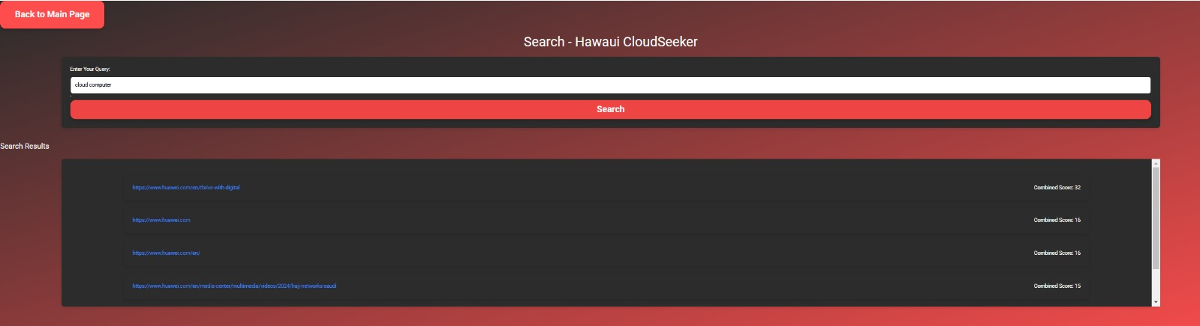 Search Screen**

The "**Search**" screen in the Huawei CloudSeeker project provides users with a powerful and transparent search interface. Below is a detailed explanation of the components and interactions on this screen:

1. **"Back to Main Page" Button**
   * **Functionality :** Redirects the user back to the main dashboard.
2. **Search Bar**
   * **Input Field :** Users can enter a query (single word or phrase) to search for relevant data in the indexed database.
   * **Autocomplete Feature** : The input field includes an autocomplete feature that suggests relevant search terms as the user types, helping them refine their query.
3. **"Search" Button**
   * **Functionality :** Triggers the search process and retrieves results from the database.
4. **Search Results Section  
   Functionality:**
   * Results are shown as a list of URLs related to the query.
   * Each result includes a "Combined Score" that represents its relevance.

**Sorting Logic:**

Results are ranked based on the score calculated by the search algorithm. Higher scores indicate higher relevance.

The score is derived from the number of occurrences of each keyword in the query.

For multi-word queries, the algorithm computes a combined score by summing the occurrences of all keywords within each URL.

**Transparency:**

The "Combined Score" is displayed alongside each result to provide users with insight into the relevance calculation.

This ensures transparency in how results are prioritized and helps users trust the system.

5. **Algorithm Transparency**

**Relevance Calculation:**

The search engine retrieves data from the index and ranks results based on their keyword occurrence frequency.

For example, if a URL contains multiple keywords from the query, its score will be higher than URLs with fewer matches.

**User Feedback:**

By showing the "Combined Score," users can understand why certain results appear at the top of the list.

This fosters trust in the system by clarifying the decision-making process behind the search results.

**Screen Overview: Statistics - Huawei CloudSeeker**

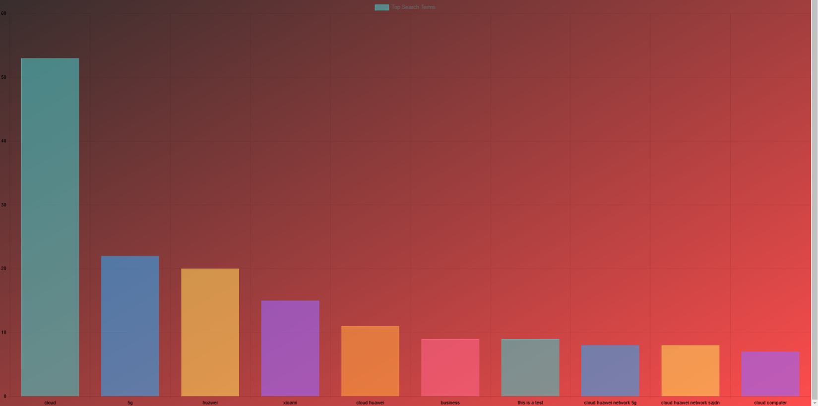

The **"Statistics"** screen in the **Huawei CloudSeeker** project allows users to view detailed statistics regarding the most searched terms. Below is a detailed explanation of the components and interactions on this screen:

1. **"Back to Main Page" Button**
   * **Functionality** : Redirects the user back to the main dashboard.
2. **"Show Top Search Terms" Button**  
   **Functionality**:
   * Displays a list of the top search terms and their associated frequency of use.
   * After clicking, the results are shown graphically as a bar chart representing the frequency of each term.
3. **Top Search Terms**
   * **Before Clicking**: The user sees an empty section prompting them to click "Show Top Search Terms" to reveal the data.
   * **After Clicking**: A bar chart is displayed, visualizing the frequency of the top search terms. Each bar represents a search term, with the length of the bar indicating the frequency of that term's use.

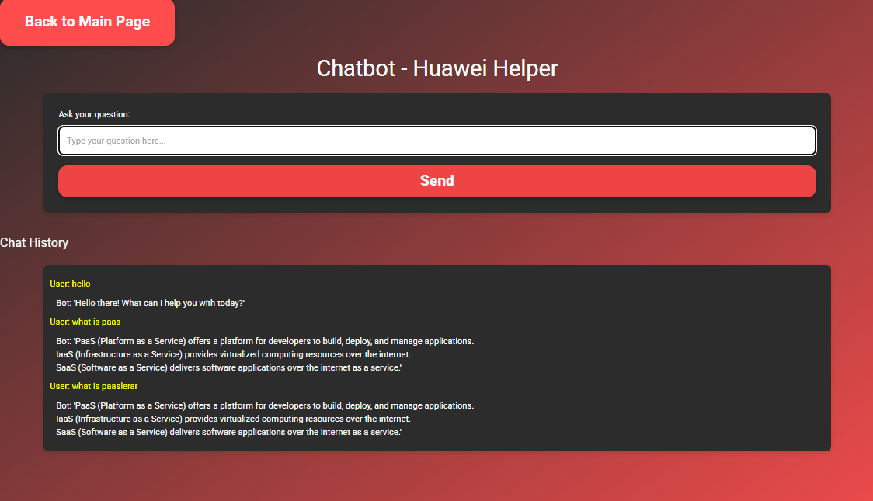**Screen Overview: Chatbot - Huawei Helper**

The **"Chatbot - Huawei Helper"** screen allows users to interact with the chatbot to get quick answers about various topics related to Huawei services and cloud computing. Below is a detailed explanation of the components and interactions on this screen:

1. **"Back to Main Page" Button**  
   * **Functionality :** Redirects the user back to the main dashboard.
2. **Ask Your Question Field**  
   * **Input Field :** Users can type their questions here to interact with the chatbot.
   * **detect and correct Feature :** The chatbot includes a feature that can detect and correct spelling errors, ensuring that even if a user makes a typo, the chatbot can still understand and provide relevant responses.
3. **"Send" Button**  
   * **Functionality :** Sends the question entered by the user to the chatbot.
4. **Chat History**  
   **Functionality:**
   * Displays the conversation history between the user and the bot. Each interaction shows the user's question and the bot's response.
   * For example, the user asks "What is PaaS?" and the bot provides an explanation:
     + **Bot**: "PaaS (Platform as a Service) offers a platform for developers to build, deploy, and manage applications."